A Project Report

On

Automated Vehicle Parking System

Submitted in partial fulfillment for award of the

Degree In

Bachelor of Technology

INFORMATION TECHNOLOGY


H. R. Institute of Technology
GHAZIABAD

20xx-20xx

Guided by : Submitted by :

jhvhvvj NAME (ROLL NO)

NAME (ROLL NO)


Department of Computer Applications

Galgotias College of Engineering and Technology,

Greater Noida

Certificate

Date: 07/05/2013

This is to certify that the dissertation entitled “AUTOMATED VEHICLE PARKING SYSTEM” by Mr. Ankita Singh and Mr. Ashok Chaudhary student of Master of computer application , of GALGOTIAS COLLEGE OF ENGINEERING AND TECHNOLOGY, GREATER NOIDA, affiliated to Gautam Budh technical university, LUCKNOW , is hereby accepted and approved as a credible work. It is further certified that this work has not been submitted for similar purpose anywhere else. His work has been found satisfactory for the partial fulfillment of the award of the degree of MCA.

Internal Examiner External Examiner

Mrs Meena Sachdeva
Mr. Sanjay Tripathi

Head of Department

Declaration

We hereby declare that the project work entitled “Automated Vehicle Parking System” is an authenticated work carried out by us. Under the guidance of Mrs Meena Sachdeva ,Mr. Sanjay Tripathi for the partial fulfillment of the award of the degree of Master of Computer ApplicationS and this work has not been submitted for similar purpose anywhere else except to GALGOTIAS COLLEGE OF ENGINEERING AND TECHNOLOGY, GREATER NOIDA, affiliated to Gautam Budh technical university, LUCKNOW .

Date: Ankita Singh(11097007)
Place: Gr. Noida Ashok Chaudhary (11097015)

ABSTRACT

The Automated Vehicle Parking System had been conceived with the view to automate the manual workflows involved in the management of Vehicle Parking Lots. It drastically reduces the effort, inaccuracies, error-prone tendencies, delays and overheads involved in performing the same tasks by hand.

It was aimed to provide a fully automated system that was capable of checking in and out of vehicles entering and exiting the designated parking lot, and recording relevant information about them. Revenue calculation and data entry is automated to the largest possible extent. Only minimum intervention from the manual user is required, with a possibility of eliminating it altogether with further advancement in the technology encompassed by the project, and supporting hardware.

A rich and easy-to-use GUI aids the user in navigating the system easily and comprehensively. Features such as multiple searching and viewing options further add to the capabilities of the system and thereby also help in reducing the entry time. Transactions concurrency and their unambiguous nature have been carefully balanced and user sessions are purposefully managed. Direct implementation of the printing code helps the entry clerks as well as managers/administrators, to print the parking slips, reports and user information as and when required.

With a marked difference in the types of users, and user privileges, the system provides a clear hierarchy and shields private data and administration details from those users, who are not permitted or concerned with them.

A lot of data mining options have also been included, in the form of managerial reports. These provide an insight into the daily working subroutines of the system, such as the total revenue collection, employee sign in times, total vehicles parked in the lot, etc. on a Daily, Monthly, or Yearly basis.

The most fundamental factor, that sets this system apart from others, is the fact that it is a real life application, designed with a specific target audience of India, taken into consideration. It makes no assumptions about the perfectionist implementation of the system, and also factors in human tendency.

For instance, it was considered that the system would automatically allocate a parking slot to each vehicle. However, this was ruled out in view of the fact that human error or misdemeanor may lead to a vehicle owner parking elsewhere, rather than the designated spot, which would lead to utter chaos. Similarly, the revenue rates have been formulated keeping the standard manual parking rates in India in mind. However, these can be changed as per requirement as well.

Acknowledgement

It is high privilege for me to express my deep sense of gratitude to all those faculty members who helped me in the completion of the project, especially my internal guide Mrs Meena Sachdeva
Mr. Sanjay Tripathi who was always there at hour of need.
My special thanks to Professor B.K.Gupta (HOD, Department of Computer Application, Galgotias College of Engineering and Technology, for helping me in the completion of project work and its report submission.

Signature:
Name : Ankita Singh
Roll No.: 11097007
Date :

Signature:
Name : Ashok Chaudhary
Roll No.: 11097015
Date :

INDEX

1. Introduction
1.1 Purpose
1.2 Scope
1.3 Definition, Acronyms and Abbreviations
1.4 Overview
2. System Analyses
2.1 Existing System
2.2 Proposed System
2.3 Feasibility study
2.4 Assumptions and Dependencies
3. Specific Requirements
3.1 External Interface
3.1.1 User Interface
3.1.2 Hardware Interface
3.1.3 Software Interface
3.1.4 Communication Interface
3.2 Functional Requirements
3.3 Performance Requirements
3.4 Design constraints
3.5 System Attributes
3.5.1 Reliability
3.5.2 Availability
3.5.3 Security
3.5.4 Maintainability
3.5.5 Portability
4. Analyses and Design
4.1 Use Case Diagram
4.1.1 Overview Use Case
4.1.2 Login Use Case
4.1.3 Manage Member Information Use Case
4.1.4 Member Use Case
4.2 Activity Diagram
4.3 Sequence Diagram
4.3.1 Sequence Diagram Overview
4.4 ER Diagram
4.4.1 ER Diagram Overview
4.5 Data Flow Diagram
4.5.1 Login Process
4.5.2 Working Process
5. User Interface Implementation
6. Database Snapshots
7. Testing
6.1 Testing Objective
6.2 Unit Testing
6.3 Integration Testing
6.4 System Testing
6.5 Acceptance Testing
8. Implementation, Evaluation & Maintenance
7.1 Implementation
7.2 Evaluation
7.3 Maintenance
9. Conclusions
10. References

- Introduction
  - Purpose:
The purpose of the report document is to specify all the information required to design, develop and test the software. The purpose of this project is to provide a friendly environment to maintain the details of books and library members.
The main purpose of this project is to maintain easy circulation system using computers and to provide different reports.

  - Definition, Acronyms, Abbreviation:
JAVA -> Platform independence
SQL -> Structured query Language
DFD -> Data Flow Diagram
CFD -> Context Flow Diagram
ER -> Entity Relationship
IDE -> Integrated Development Environment
SRS -> Software Requirement Specification

  - Overview:
Everyone who owns or drives a vehicle in India or abroad would be all too familiar with the hassles of finding parking spaces, misbehaving parking attendants, inconsistent or monopolized rates and other problems associated with it.

What is proposed here, is not just another automation of a manual workflow system, it can also be viewed as a solution to the aforementioned problems of the everyday consumer. Rise to the occasion, an Automated Vehicle Parking System.

It not only rids the vehicle owner from the hassles of finding parking spots, it ensures that there is never over or under accommodation of vehicles beyond the lot’s capacity. The system completely eliminated even the possibility of embezzlements. The rates are fixed and predefined. No tampering can be done with the automated calculation of the revenue based on the time taken directly from the console.

- System Analyses

  - Existing System:
Some of the problems being faced in Existing system are as follows:
1. Fast report generation is not possible.
2. Tracing a book is difficult.
3. Information about issue/return of the books are not properly maintained.
4. No central database can be created as information is not available in database.

  - Proposed System:
The proposed Library Management System will take care of the current book detail at any point of time. The book issue, book return will update the current book details automatically so that user will get the update current book details.

  - Feasibility study:
The overall scope of the feasibility study was to provide sufficient information to allow a decision to be made as to whether the Library Management System project should proceed and if so, its relative priority in the context of other existing Library Management Technology.
The feasibility study phase of this project had undergone through various steps which as describe as under:
- Identity the origin the information at different level.
- Identity the expectation of user from computerized system.
- Analyze the drawback of existing system(manual system)
  - Assumption and dependencies:
All the data entered will be correct and up to date. This software package is developed using java as front end which is supported by sun micro system. Microsoft SQL server as the back end.

- Specific Requirements

  - External Interface Requirement:
The user should be simple and easy to understand and use. Also be an interactive interface .The system should prompt for the user and administrator to login to the application and for proper input criteria
    - User Interface:

The software provides good graphical interface for the user any administrator can operate on the system, performing the required task such as create, update, viewing the details of the book.
- Allows user to view quick reports like Book Issues/Returned etc in between particular time.
- Stock verification and search facility based on different criteria.

    - Hardware Interface:
- Operating system : window
- Hard disk :160 GB
- RAM : 512 MB
- Processor : Pentium(R)Dual-core CPU

    - Software Interface:
- Java language
- Net beans IDE
- Oracle DB server
    - Communication Interface:
Window
  - Functional requirements:

- Book entry: In this module we can store the details of the books.
- Manage Users: In this module we can manage all users.
- Book issue: This module is used to keep a track of book issue details.
- Book return: This module enables to keep a track of return the books.
  - Performance requirements:

The capability of the computer depends on the performance of the software. The software can take any number of inputs provided the database size is larger enough. This would depend on the available memory space.
  - Design constraints:
Each member will be having a identity card which can be used for the library book issue, fine payment etc. whenever library member wish to take a book, the book issued by the library authority will be check both the book details as well as the student details and store it in library database. In case of retrieval of book much of human intervention can be eliminated.
  - System attributes:
    - Maintainability: There will be no maintained requirement for the software. The database is provided by the end user and therefore is maintained by this user.
    - Portability: The system is developed for secured purpose, so it is can’t be portable.
    - Availability: This system will available only until the system on which it is install, is running.
    - Scalability: Applicable.

- Analyses and Design

  - Use Case Diagram:

    - Use Case Overview:

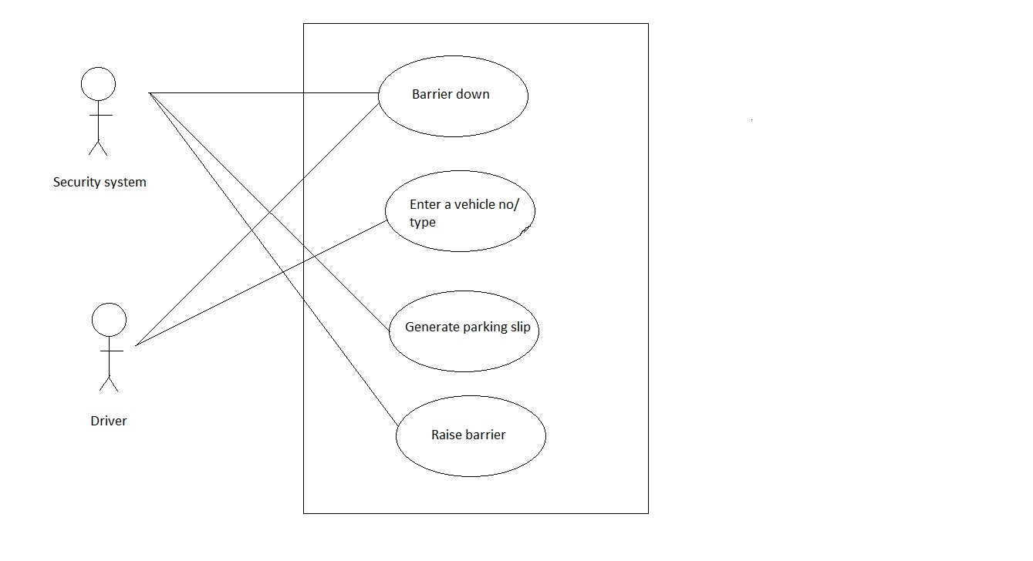.

    - Login User Case:
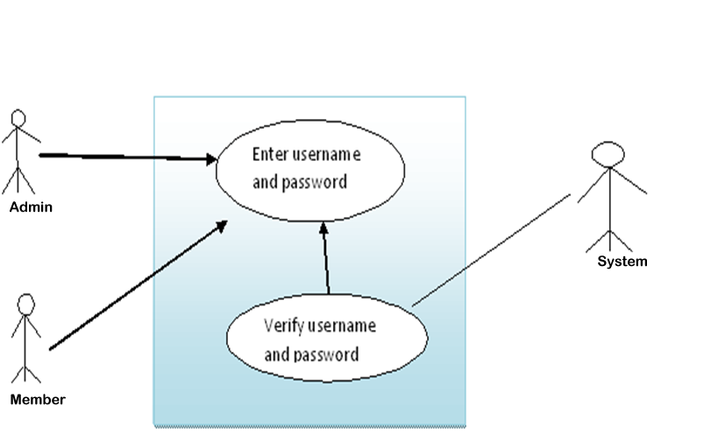

    - Manage Member Information Use Case:

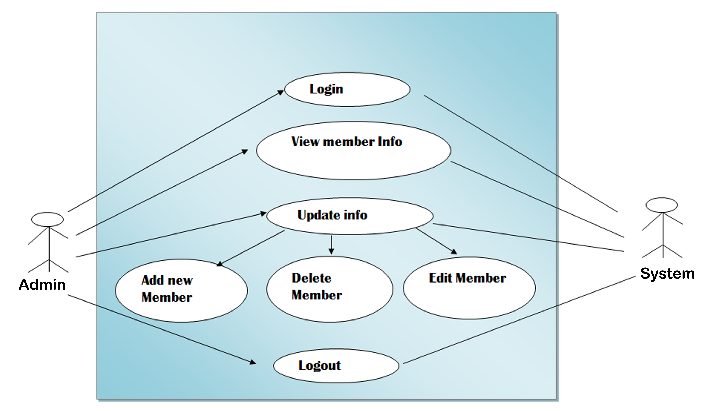

  - Activity Diagram:
Activity diagrams are graphical representations of workflows of stepwise activities and actions with support for choice, iteration and concurrency. In the Unified Modeling Language, activity diagrams can be used to describe the business and operational step-by-step workflows of components in a system. An activity diagram shows the overall flow of control.
Activity diagrams are constructed from a limited repertoire of shapes, connected with arrows. The most important shape types:
- rounded rectangles represent activities;
- diamonds represent decisions;
- bars represent the start (split) or end (join) of concurrent activities;
- a black circle represents the start (initial state) of the workflow;
- an encircled black circle represents the end (final state).
Arrows run from the start towards the end and represent the order in which activities happen.
Hence they can be regarded as a form of flowchart. Typical flowchart techniques lack constructs for expressing concurrency. However, the join and split symbols in activity diagrams only resolve this for simple cases; the meaning of the model is not clear when they are arbitrarily combined with decisions or loops.
    - Login Activity Diagram:
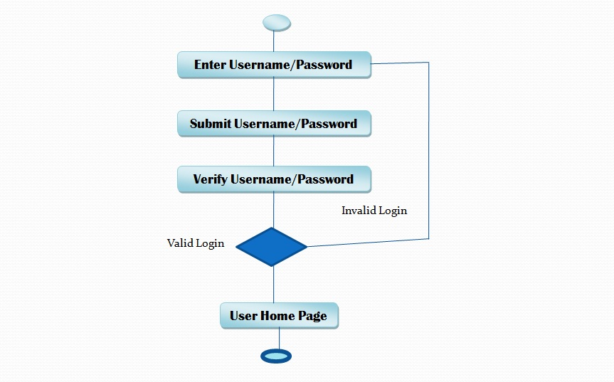

  - Sequence Diagram:
A sequence diagram is a kind of interaction diagram that shows how processes operate with one another and in what order. It is a construct of a Message sequence chart. A sequence diagram shows, as parallel vertical lines (lifelines), different processes or objects that live simultaneously, and, as horizontal arrows, the messages exchanged between them, in the order in which they occur.

    - Sequence Diagram Overview:

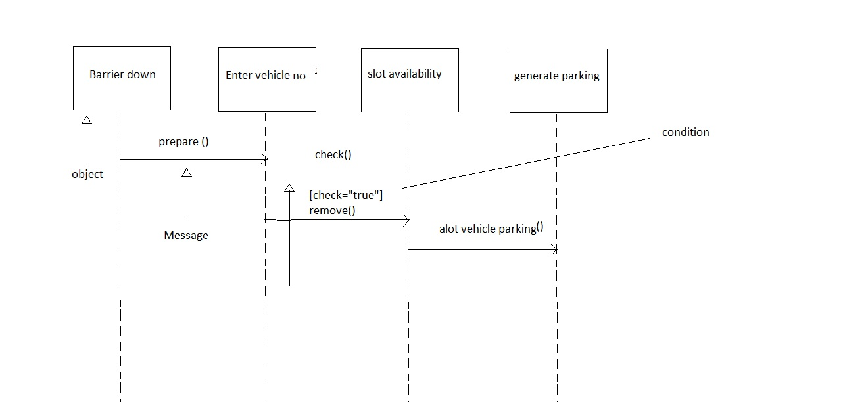.
  - ER Diagram:
It is clear that the physical objects from the previous section – the member, books, and library – correspond to entities in the Entity-Relationship model, and the operations to be done on those entities – holds, checkouts, and so on – correspond to relationships. However, a good design will minimize redundancy and attempt to store all the required information in as small a space as possible.

    - ER Diagram Overview:

.
PARKING AREA
VehicleType
Password
UserID

EmpType
EmpName
Status

TotalSlots

VacantSlots

FloorNo

VehicleType
EMPLOYEE
VEHICLE
VehicleNo
FloorNo

Revenue

SlipNo

TimeOut
TimeIn
SlipStatus

Enters Details of
Enters In/ Exits From
1
1..*
1..*
1..*
Logs Into/ Out From
LOGIN
1..*
1
UserID

Password
TerminalNo
EmpInTime
EmpOutTime
  - Data Flow Diagram (DFD):
A data flow diagram (DFD) is a graphical representation of the "flow" of data through an information system. DFDs can also be used for the visualization of data processing (structured design).
On a DFD, data items flow from an external data source or an internal data store to an internal data store or an external data sink, via an internal process.
A DFD provides no information about the timing of processes, or about whether processes will operate in sequence or in parallel. It is therefore quite different from a flowchart, which shows the flow of control through an algorithm, allowing a reader to determine what operations will be performed, in what order, and under what circumstances, but not what kinds of data will be input to and output from the system, nor where the data will come from and go to, nor where the data will be stored (all of which are shown on a DFD).

    - Login Process:
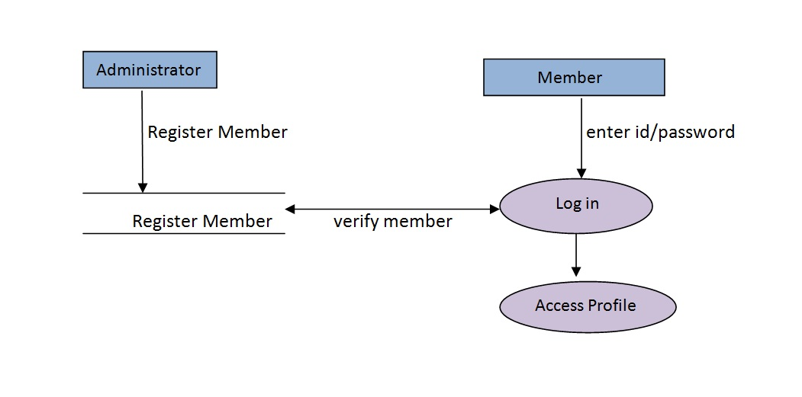
    - Working Process
AUTOMATED VEHICLE PARKING SYSTEM
Clerk
Clerks
Vehicle Type
Vehicle No.
Manager
Reports
Parking Slips
Report/User
Details
Slip/Vehicle No.

Fig: 0 Level DFD
1 Level DFD
IN Terminal
Clerk

Manager
Parking slips
Vehicle Type
Vehicle No.

DATABASE (AVPS)
Manager
Terminal
OUT Terminal
Report/User
Details

Clerk

Slip/Vehicle No.
Reports

- DataBase Tables

- User Interface Implementation

  - Login:

  - Admin Main Page:

- Testing

  - Testing Objective:
The main objective of testing is to finding a host of errors, systematically and with minimum effort and time. We can say as follows:
- Testing is a process of executing a program with the intent of finding an error.
- A good test case is one that has a high probability of finding error, if it exists.
- The tests are inadequate to detect possibly present errors.
- The software should be based on the quality and reliable standards.

  - Unit testing:
Unit testing focuses verification effort on the smallest unit of software i.e. the module. Using the detailed design and the process specifications, testing is done to uncover errors within the boundary of the module. All modules must be successful in the unit test before the start of the integration testing begins.
In this project each service can be thought of a module. There are so many modules like administrator,user,visitor. Each module has been tested by giving different sets of inputs. When developing the module as well as finishing the development, the module works without any error. The inputs are validated when accepting them from the user.
  - Integrated testing:
After unit testing, we have to perform integration testing. The goal here is to see if modules can be integrated properly, the emphasis being on testing interfaces between modules. This testing activity can be considered as testing the design and hence the emphasis on testing module interactions.
In this project the main system is formed by integrating all the modules. When integrating all the modules I have checked whether the integration effects working of any of the services by giving different combinations of inputs with which the two services run perfectly before integration.
  - System testing:
System testing involved is the most widely used testing process consisting of five stages as shown in the figure. In general, the sequence of testing activities is component testing, integration testing, and then user testing. However, as defects are discovered at any one stage, they require program modifications to correct them and this may require other stages in the testing process to be repeated.

Unit testing
Module testing
Acceptance testing
Sub-system testing
System testing

(Component testing) (Integration testing) (User testing)

Fig. show Prototype model

Testing is the process of detecting errors. Testing performs a very critical role for quality assurance and for ensuring the reliability of the software. The results of testing are used later on during maintenance also.
Testing is vital to the success of the system. System testing makes a logical assumption that if the parts of the system are correct, the goal will be successfully achieved. In adequate testing or non-testing leads to errors that may not appear until months or even years later. This creates two problems:
- The time lag between the cause and the appearance of the problem.
- The time interval effect of the system errors on files and the records on the system.
A small error can conceivably explode into a much larger problem. Effective testing early in the process translates directly into long term cost savings from a reduced number of errors.
Another reason for system testing is its utility as a user oriented vehicle before implementation. The best program is worthless if it does not meet the user requirements. Unfortunately, the user’s demands are often compromised by efforts to facilitate program or design efficiency in terms of processing time or design efficiency.
Thus in this phase we went to test the code we wrote. We needed to know if the code compiled with the design or not? Whether the code gave the desired outputs on given inputs? Whether it was ready to be installed on the user’s computer or some more modifications were needed?
Through the web applications are characteristically different from their software counterparts but the basic approach for testing these web applications is quite similar. These basic steps of testing have been picked from software engineering practices. The following are the steps, we undertook:
The content of the Intranet site is reviewed to uncover content errors. Content errors covers the typographical errors, grammatical errors, errors in content consistency, graphical representation and cross referencing errors.
The design model of the web application is reviewed to uncover the navigation errors. Use cases, derived as a part of the analysis activity allows a web designer to exercise each usage scenario against the architectural and navigational design. In essence these non-executable tests help to uncover the errors in navigation.
When web applications are considered the concept of unit changes. Each web page encapsulates content navigation links, content and processing elements. It is not always possible to test each of these individually. Thus is the base of the web applications the unit to be considered is the web page. Unlike the testing of the algorithmic details of a module the data that flows across the module interface, page level testing for web applications is driven by content, processing and links encapsulating the web page.
The assembled web application is tested for overall functionality and content delivery. The various user cases are used that test the system for errors and mistakes. The web application is tested for a variety of environmental settings and is tested for various configurations and upon various platforms.
The modules are integrated and integration test are conducted. Thread based testing is done to monitor the regression tests so that the site does not become very slow is a lot of users are simultaneously logged on.

Levels of Testing
In order to finding the errors present in different phases, we have the concept of levels of testing. The basic levels of testing are
Client Needs
Requirements
Design
Code
Acceptance Testing
System Testing
Integration Testing

Unit Testing

  - Acceptance testing:
Acceptance Testing is performed with realistic data of the client to demonstrate that the software is working satisfactorily. Testing here is focused on external behavior of the system of the internal logic of program is not emphasized.
Test cases should be selected so that the largest number of attributes of an equivalence class is exercised at once. The testing phase is an important part of software development. It is the process of finding errors and missing operations and also a complete verification to determine whether the objectives are met and the user requirements are satisfied.

Software testing is an investigation conducted to provide stakeholders with information about the quality of the product or service under test. Software testing also provides an objective, independent view of the software to allow the business to appreciate and understand the risks at implementation of the software. Test techniques include, but are not limited to, the process of executing a program or application with the intent of finding software bugs.
Software testing can also be stated as the process of validating and verifying that a software program/application/product:
- meets the business and technical requirements that guided its design and development;
- works as expected; and
- can be implemented with the same characteristics

Functional Vs Non-functional Testing
Functional testing refers to tests that verify a specific action or function of the code. These are usually found in the code requirements documentation, although some development methodologies work from use cases or user stories. Functional tests tend to answer the question of "can the user do this" or "does this particular feature work".
Non-functional testing refers to aspects of the software that may not be related to a specific function or user action, such as scalability or security. Non-functional testing tends to answer such questions as "how many people can log in at once", or "how easy is it to hack this software".

Static Vs Dynamic Testing
There are many approaches to software testing. Reviews, walkthroughs, or inspections are considered as static testing, whereas actually executing programmed code with a given set of test cases is referred to as dynamic testing. Static testing can be (and unfortunately in practice often is) omitted. Dynamic testing takes place when the program itself is used for the first time (which is generally considered the beginning of the testing stage). Dynamic testing may begin before the program is 100% complete in order to test particular sections of code (modules or discrete functions). Typical techniques for this are either using stubs/drivers or execution from a debugger environment. For example, spreadsheet programs are, by their very nature, tested to a large extent interactively ("on the fly"), with results displayed immediately after each calculation or text manipulation.

Software Quality Assurance (SQA)
Though controversial, software testing may be viewed as an important part of the software quality assurance (SQA) process. In SQA, software process specialists and auditors take a broader view on software and its development. They examine and change the software engineering process itself to reduce the amount of faults that end up in the delivered software: the so-called defect rate.
What constitutes an "acceptable defect rate" depends on the nature of the software. For example, an arcade video game designed to simulate flying an airplane would presumably have a much higher tolerance for defects than mission critical software such as that used to control the functions of an airliner that really is flying!
Although there are close links with SQA, testing departments often exist independently, and there may be no SQA function in some companies.
Software testing is a task intended to detect defects in software by contrasting a computer program's expected results with its actual results for a given set of inputs. By contrast, QA (quality assurance) is the implementation of policies and procedures intended to prevent defects from occurring in the first place.

Testing Methods

The Box Approach
Software testing methods are traditionally divided into and white- and black-box testing. These two approaches are used to describe the point of view that a test engineer takes when designing test cases.

White Box Testing
White box testing is when the tester has access to the internal data structures and algorithms including the code that implement these. White box testing methods can also be used to evaluate the completeness of a test suite that was created with black box testing methods. This allows the software team to examine parts of a system that are rarely tested and ensures that the most important function points have been tested.

Black Box Testing
Black box testing treats the software as a "black box"—without any knowledge of internal implementation. Black box testing methods include: equivalence partitioning, boundary value analysis, all-pairs testing, fuzz testing, model-based testing, traceability matrix, exploratory testing and specification-based testing.

Grey Box Testing

Grey box testing (American spelling: gray box testing) involves having knowledge of internal data structures and algorithms for purposes of designing the test cases, but testing at the user, or black-box level. Manipulating input data and formatting output do not qualify as grey box, because the input and output are clearly outside of the "black-box" that we are calling the system under test. This distinction is particularly important when conducting integration testing between two modules of code written by two different developers, where only the interfaces are exposed for test. However, modifying a data repository does qualify as grey box, as the user would not normally be able to change the data outside of the system under test. Grey box testing may also include reverse engineering to determine, for instance, boundary values or error messages.

- Implementation, Evaluation & Maintenance

  - Implementation:
System implementation is the stage when the user has thoroughly tested the system and approves all the features provided by the system. The various tests are performed and the system is approved only after all the requirements are met and the user is satisfied.
The new system may be totally new, replacing an existing manual or automated system, or it may be a major modification to an existing system. In case of, proper implementation is essential to provide a reliable system to meet organizational requirements. Successful implementation may not guarantee improvement in the organization using the new system, but improper will prevent it.
Implementation is the process of having systems personnel check out and put new equipment into use, train users, install the new application and construct any files of data needed to use it. This phase is less creative than system design. Depending on the size of the organization that will be involved in using the application and the risk involved in its use, systems developers may choose to test the operation in only one area of the firm with only one or two persons. Sometimes, they will run both old and new system in parallel way to compare the results. In still other situations, system developers stop using the old system one day and start using the new one the next.

  - Evaluation:
The evaluation phase ranks vendor proposals and determines the one best suited. Evaluation of the system is performed to identify its strengths and weaknesses. The actual evaluation can occur along any of the following dimensions:

Operational Evaluation
Assessment of the manner in which the system functions, including case of use, response time, overall reliability and level of utilization.

Organizational Impact
Identification and measurement of benefits to the organization in such areas, as financial concerns, operational efficiency and competitive impact.
Development Performance
Evaluation of the development process in accordance with such yardsticks as overall development time and effort, conformance to budgets and standards and other project management criteria.
  - Maintenance:
Maintenance or enhancement can be classified as
- Corrective
- Adaptive
- Perfective
Corrective maintenance means repairing processing or performance failures or making changes because of previously uncorrected problems or false assumptions. Adaptive maintenance means changing the program function. Perfective maintenance means enhancing the performance or modifying the programs to respond to the user’s additional or changing needs.
Maintenance is actually the implementation of the post implementation review plan. As important as it is, many programmers and analysts are reluctant to perform or identify themselves with the maintenance effort. There are psychological, personality and professional reasons for this. In any case, a first class effort must be made to ensure that software changes are made properly and in time to keep the system in tune with user specifications.
Maintenance is costly. One way to reduce maintenance costs is through maintenance management and software modification audits. Software modification consists of program rewrites system level updates, and re-audits of low ranking programs to verify and correct the soft spots. The outcome should be more reliable software, a reduced maintenance backlog, and higher satisfaction and morale among the maintenance staff.

- Conclusion

From a proper analysis of positive points and constraints on the component, it can be safely concluded that the product is a highly efficient GUI based component. This application is working properly and meeting to all user requirements. This component can be easily plugged in many other systems.

- References

- http://www.java2s.com/
- http://docs.oracle.com/javase/tutorial/java/TOC.html
- Database Programming with JDBC and Java by O'Reilly
- Head First Java
- A Programmer's Guide to Java (Khalid A. Mughal and Rolf w. Rasmussen)

